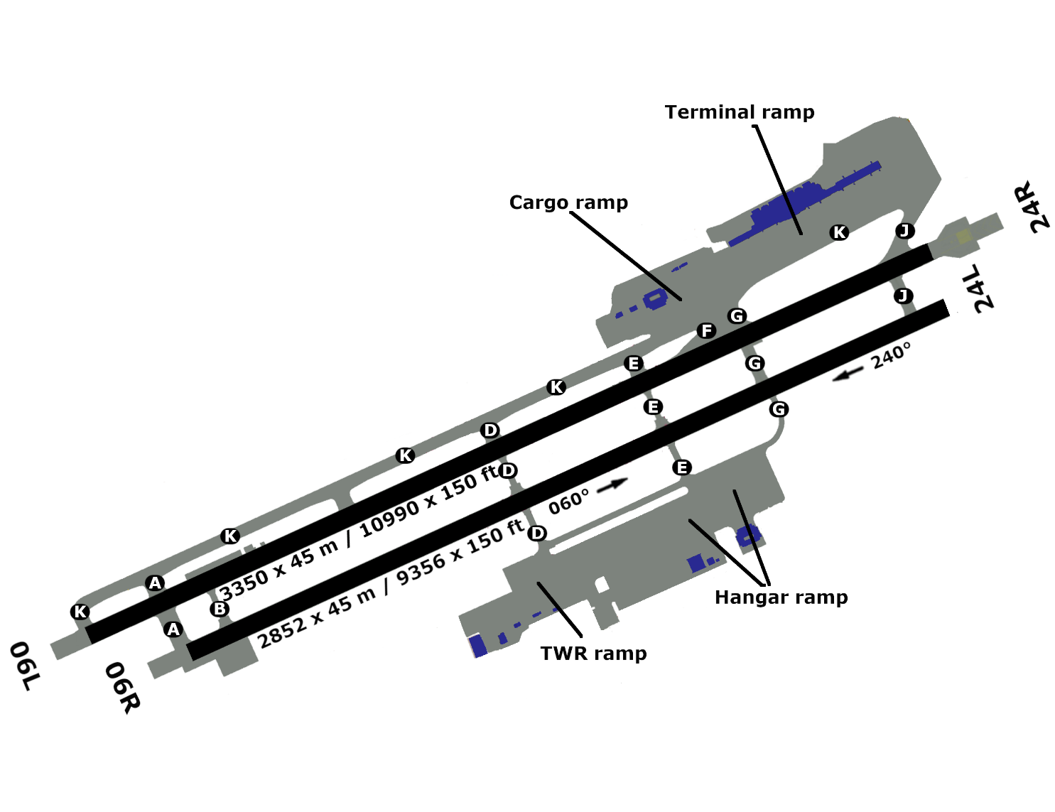

PGUM - ANTONIO B. WON PAT
110.30
144°47”05’E
13°28”46’N
1.0
301 ft
231 ft
305 ft
24L
24R
3350 m
3350 m
2852 m
2852 m
06R
06L
234 ft

